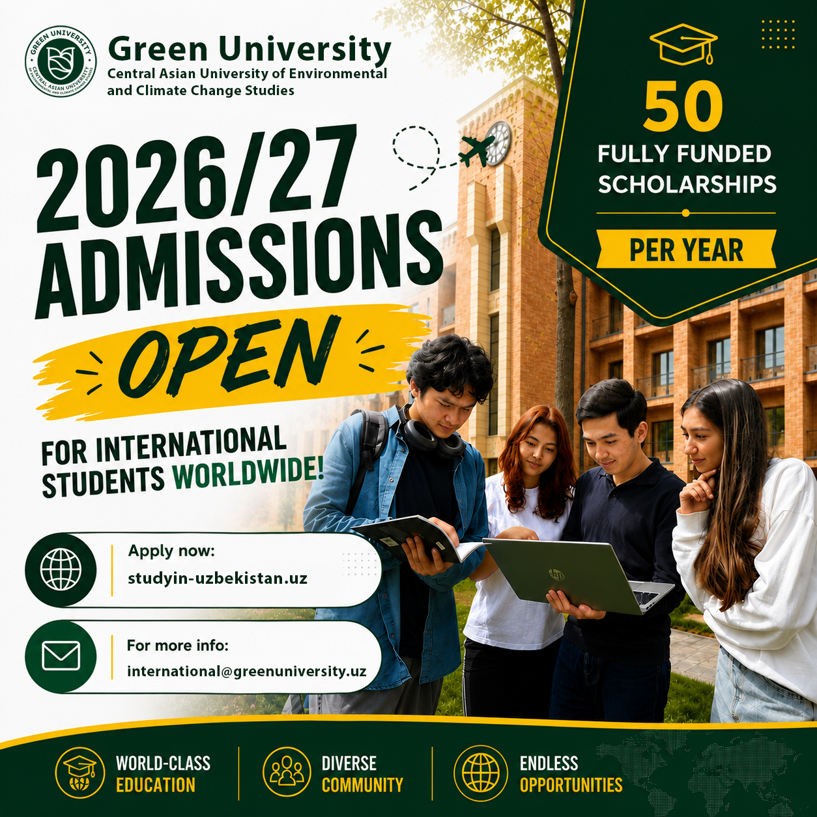

🚀ADMISSIONS 2026 NOW OPEN AT GREEN UNIVERSITY (FOR INTERNATIONAL APPLICANTS)
📣 Are you ready to become a leader of sustainable change?
Green University welcomes international applicants to join one of the most forward-thinking academic environments in Central Asia.
🔴Bachelor’s Degree Programs:
✅ Environment & Sustainable Management
✅ Ecology and Public Administration
✅ Jurisprudence
✅ Green Economy
🚫 Master’s Degree Programs:
🔴 Sustainable Development
🔴 Environmental Law
🔴 Circular Economy
🔴 Sustainable Tourism
🔴 Sustainable Finance
🔴 Environmental Science, Analysis and Management
🔴 Environmental Protection (Nature Conservation)
🖥 Apply now: https 👉 https://studyin-uzbekistan.uz/universities/256
✉️For more info 👉 international@greenuniversity.uz
_______________________________________
✉️ info@caguniversity.uz
☎️ +998555120077
📍Location
🌐Website | 📱Telegram | 📱Instagram | 📱LinkedIn | 🟥YouTube

