  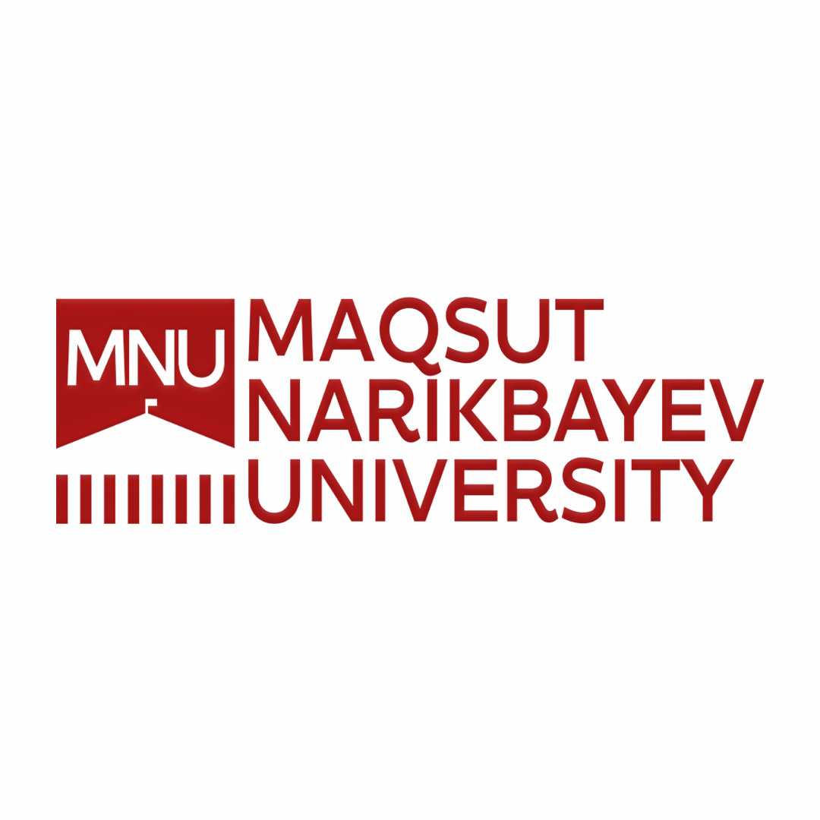 | Student Exchange Program Application  International Office  MAQSUT NARIKBAYEV UNIVERSITY,  Korgalzhyn highway 8, 010000  Astana, Kazakhstan  tel: +7 7172 70 30 31
  Passport Style Digital Photo
  Please also submit as a separate file

PERSONAL INFORMATION

Name:____________________________________________________________________________________ (Miss, Mrs., Mr.) (Last) (Given)

Mailing Address for Admissions Documents:_____________________________________________________

Phone Number:________________________________ E-mail Address:____________________________

Date of Birth:__________________________________ Nationality:_______________________________

Passport Number:_______________________________ Spoken Languages:_________________________

Language | Reading | Writing | Listening | Speaking
Kazakh | Excellent / Good / Fair | Excellent / Good / Fair | Excellent / Good / Fair | Excellent / Good / Fair
Russian | Excellent / Good / Fair | Excellent / Good / Fair | Excellent / Good / Fair | Excellent / Good / Fair
English | Excellent / Good / Fair | Excellent / Good / Fair | Excellent / Good / Fair | Excellent / Good / Fair
Other Languages

Emergency Contact Person:_______________________ Email:____________________________________

Address:__________________________________________________________________________________

_________________________________________________________________________________________

ACADEMIC INFORMATION

Institution you are currently attending:__________________________________________________________

Present year of study:____________________________ Major:____________________________________

Degree:____________________________ G.P.A.:___________________________________

APPLICATION MATERIALS to be submitted via email to mobility@kazguu.kz
- Forms must be filled in digitally. No handwriting.
- Application Form
- Current Transcript
- Certificate of Enrollment
- Passport Copy (information page)

Date Application Completed:______________________________

